In Kali Terminal
┌──(kali㉿kali)-[~]
└─$ ifconfig
eth0: flags=4163<UP,BROADCAST,RUNNING,MULTICAST> mtu 1500
inet 192.168.27.131 netmask 255.255.255.0 broadcast 192.168.27.255
inet6 fe80::6c8d:3ebd:4a00:5c4e prefixlen 64 scopeid 0x20<link>
ether 00:0c:29:d1:aa:d1 txqueuelen 1000 (Ethernet)
RX packets 696 bytes 375514 (366.7 KiB)
RX errors 0 dropped 0 overruns 0 frame 0
TX packets 723 bytes 76748 (74.9 KiB)
TX errors 0 dropped 0 overruns 0 carrier 0 collisions 0
device interrupt 19 base 0x2000
lo: flags=73<UP,LOOPBACK,RUNNING> mtu 65536
inet 127.0.0.1 netmask 255.0.0.0
inet6 ::1 prefixlen 128 scopeid 0x10<host>
loop txqueuelen 1000 (Local Loopback)
RX packets 2216 bytes 332559 (324.7 KiB)
RX errors 0 dropped 0 overruns 0 frame 0
TX packets 2216 bytes 332559 (324.7 KiB)
TX errors 0 dropped 0 overruns 0 carrier 0 collisions 0
In Windows Command Prompt
C:\Users\student>ipconfig
Windows IP Configuration
Ethernet adapter Ethernet:
Connection-specific DNS Suffix . :
IPv4 Address. . . . . . . . . . . : 172.16.225.3
Subnet Mask . . . . . . . . . . . : 255.255.0.0
Default Gateway . . . . . . . . . : 172.16.225.254
Ethernet adapter VirtualBox Host-Only Network:
Connection-specific DNS Suffix . :
IPv4 Address. . . . . . . . . . . : 192.168.56.1
Subnet Mask . . . . . . . . . . . : 255.255.255.0
Default Gateway . . . . . . . . . :
Wireless LAN adapter Wi-Fi:
Media State . . . . . . . . . . . : Media disconnected
Connection-specific DNS Suffix . :
Wireless LAN adapter Local Area Connection* 1:
Media State . . . . . . . . . . . : Media disconnected
Connection-specific DNS Suffix . :
Wireless LAN adapter Local Area Connection* 2:
Media State . . . . . . . . . . . : Media disconnected
Connection-specific DNS Suffix . :
Ethernet adapter VMware Network Adapter VMnet1:
Connection-specific DNS Suffix . :
IPv4 Address. . . . . . . . . . . : 192.168.153.1
Subnet Mask . . . . . . . . . . . : 255.255.255.0
Default Gateway . . . . . . . . . :
Ethernet adapter VMware Network Adapter VMnet8:
Connection-specific DNS Suffix . :
IPv4 Address. . . . . . . . . . . : 192.168.27.1
Subnet Mask . . . . . . . . . . . : 255.255.255.0
Default Gateway . . . . . . . . . :
Ethernet adapter Bluetooth Network Connection:
Media State . . . . . . . . . . . : Media disconnected
Connection-specific DNS Suffix . :
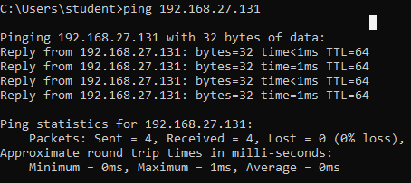
To block the IP Packets
┌──(kali㉿kali)-[~]
└─$ sudo iptables -A INPUT -s 192.168.27.1 -j DROP
[sudo] password for kali:
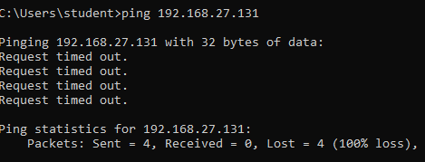
To unblock the IP Packets
┌──(kali㉿kali)-[~]
└─$ sudo iptables -D INPUT -s 192.168.27.1 -j DROP
[sudo] password for kali:
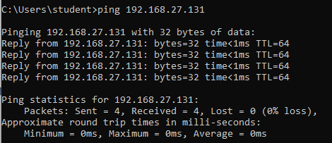
To block the port 80
┌──(kali㉿kali)-[~]
└─$ sudo iptables -A INPUT -s 192.168.27.1 -p tcp --destination-port 80 -j DROP
In windows browser search for kali ip address
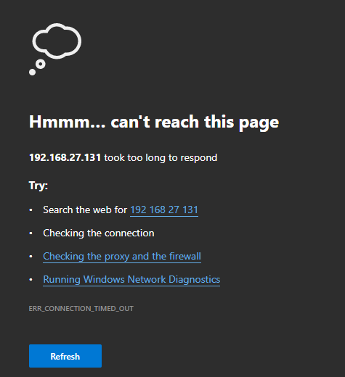
To unblock the port 80
┌──(kali㉿kali)-[~]
└─$ sudo iptables -D INPUT -s 192.168.27.1 -p tcp --destination-port 80 -j DROP
In windows browser search for kali ip address apache2 default page will be opened.
